Azure Load Balancer for VNN. Below are the settings for Inbound rules while setting up ALB
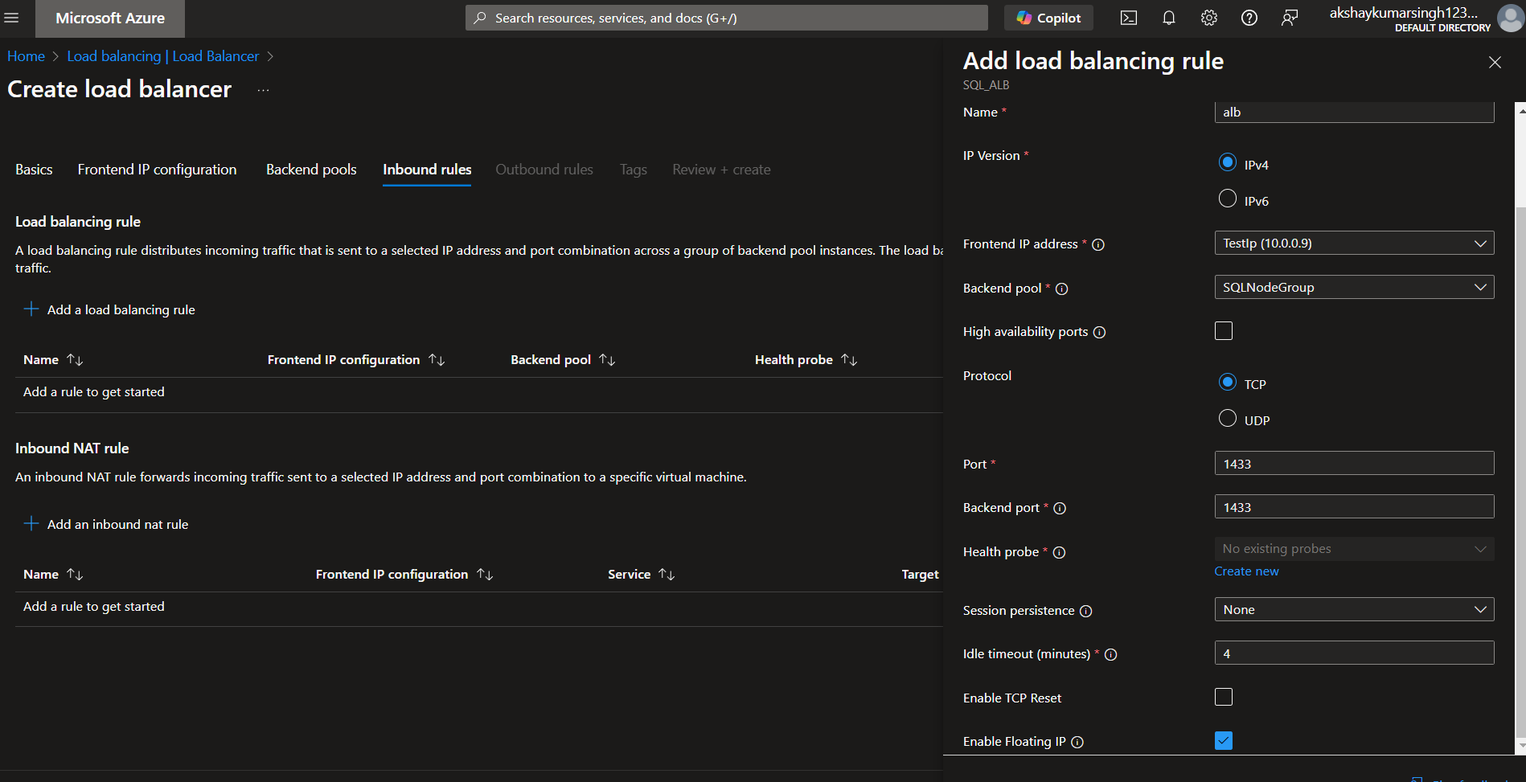
Allocate Static IP to 2019 Windows Cluster using this command
New-Cluster -Name MyCluster -Node Node1,Node2 -StaticAddress 192.168.1.100 -NoStorage -AdministrativeAccessPoint ActiveDirectoryAndDns -ManagementPointNetworkType Singleton

